CHM 2050 Mock Lab Final Name ____________
TA___________________ Section _________

Question 1
If I have an impure solid and I were to take its’ melting point and then I were to recrystallize it and re-measure the melting point, would the melting point change and if so, how and why?

Pure substances melt at defined temperatures, but mixtures of organic compound melt over a range that is lower than the melting point of each of the components. This gives you an easy way to see if two organic solids are the same substance: Mix some of each and see if the mixture melts over a range that is lower than either of the two components.

Question 2
What are the 6 basic steps for recrystallizing an impure solid?
1. Dissolve the crude material in a minimum amount of hot solvent.
2. Treat with decolorizing charcoal.
3. Filter the hot solution to remove charcoal and other insoluble impurities.
4. Cool to cause crystallization.
5. Filter the crystals, washing to remove adhering solvent and soluble impurities.
6. Dry the crystals to remove the last traces of solvent

Question 3
What are 4 characteristics of good recrystallization solvents?
1) Inert to your material
2) Your material needs to be highly soluble in hot solvent.
3) Your material needs to be insoluble in cold solvent.
4) Your impurities should not be soluble in the solvent.

Question 4
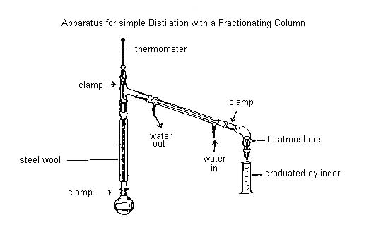
Draw and label the parts of a simple distillation apparatus
(leave out the fractionating column)

Question 5
If I were to present you with a mixture of benzoic acid and m-tolylamine, how would you separate them? You can use any inorganic reagents you desire. Describe your procedures with a flowchart.

BAH = Benzoic acid
mTA = m-tolylamine

Question 6
Define R_{f} and draw a tlc plate with three spots and show how the R_{f} value of each spot would be measured.

Figure 2. TLC separation. (a) before development; (b) and (c) the components move proportionately to the solvent front. The R_{f} of the fastest moving spot is given by y/x. (d) Broad spots result in poor separation when your spots are too big.

Question 7
What position of the various aromatic compounds would be isolated?

Question 8
a) Draw the complete mechanism for the reaction of n-pentanol with HBr under reflux conditions
b) Draw the complete mechanism for the reaction of 2-methyl-2-butanol with HBr under reflux conditions.
a
b

Question 9
Acetic anhydride is the acetylating agent most commonly used to make aspirin. Draw the mechanism for the reaction listed below:

Question 10
If you are given the following alcohols, describe how it would respond to the Jones oxidation, Bromination, aqueous NaOH, and ZnCl₂/HCl:

 | Primary  Alcohol | Secondary  Alcohol | Tertiary  Alcohol | Phenol | Ether
aqueous NaOH | insoluble | insoluble | insoluble | soluble | insoluble
Br₂ | negative | negative | negative | positive | negative
CrO₃ | positive | positive | negative | positive | negative
ZnCl₂/HCI | negative | slow reaction | fast reaction | negative | Negative
 | A is primary | C is secondary | D is tertiary | B is a phenol

Question 11
When we identify our aldehydes and ketones, we use a variety of tests including the 2,4-Dinitrophenylhydrazine Test. Please describe the test and why this test is among the most useful identification methods that we can use to identify unknowns.

These particular derivatives are used because they can be made with great reliability and they are nicely crystalline

Question 12
Describe the reaction between hexanediamine and decanedioyl chloride:

This is a peptide or amide bond.

Question 13
Draw the aldol condensation product of 2 acetone molecules that is catalyzed by NaOH.

